**Traffic Management System Using IoT**

A **Traffic Management System (TMS)** is a system that uses **Internet of Things (IoT)** technology to manage traffic flow and improve road safety. It involves the use of various sensors, cameras, and other devices to collect real-time data on traffic conditions and then analyze and process this data to make informed decisions.

This system utilizes live video stream analysis, image processing, cloud computing, and artificial neural networks to predict high levels of traffic congestion and manage traffic effectively. By analyzing data collected from sensors, it can provide insights into traffic patterns and help reduce congestion in major cities

**Project Definition**

The project involves using IoT devices and data analytics to monitor traffic flow and congestion in real-time, providing commuters with access to this information through a public platform or mobile apps. The objective is to help commuters make informed decisions about their routes and alleviate traffic congestion. This project includes defining objectives, designing the IoT traffic monitoring system, developing the traffic information platform, and integrating them using IoT technology and Python.

**Problem Definition**

**Problem Statement:** Lack of an efficient traffic management system to replace the faulty and inefficient manual system, leading to congestion and delays in traffic flow, especially during peak hours and emergencies.

The problem is to develop a comprehensive Traffic Management System (TMS) that utilizes Internet of Things (IoT) technologies to improve traffic flow, safety, and efficiency in urban and suburban areas. This system aims to address various challenges related to traffic congestion, accidents, pollution, and the overall quality of life in densely populated regions.

**Key Objectives:**

Real-time Traffic Monitoring: Create a network of IoT sensors and devices to collect real-time data on traffic conditions, including vehicle density, speed, and road conditions.

**Traffic Data Analysis:** Implement data analytics and machine learning algorithms to process the collected traffic data and derive valuable insights. This includes identifying congestion patterns, accident detection, and predicting traffic trends.

**Traffic Signal Optimization:** Optimize traffic signal timings dynamically based on real-time traffic data to reduce congestion and minimize waiting times at intersections.

**Smart Parking Solutions:** Develop a system to guide drivers to available parking spaces using IoT sensors in parking lots and streets. This will reduce unnecessary traffic caused by drivers searching for parking.

**Emergency Response Integration:** Incorporate IoT devices and communication protocols to enable rapid response to accidents and emergencies, such as automatically changing traffic signals to facilitate the passage of emergency vehicles.

**Public Transportation Integration**: Integrate IoT technologies with public transportation systems to provide real-time information to commuters, including bus and train schedules, delays, and alternative routes.

**Environmental Impact Mitigation:** Monitor air quality and emissions in urban areas using IoT sensors to promote environmentally friendly transportation methods and reduce pollution.

**User-Friendly Interfaces:** Develop user-friendly mobile and web applications that provide real-time traffic information, navigation assistance, and alerts to users, enabling them to make informed decisions about their routes and travel times.

**Data Security and Privacy**: Implement robust security measures to protect the integrity and privacy of the data collected by IoT devices, ensuring that sensitive information remains confidential.

**Scalability and Future-Readiness:** Design the system to be scalable and adaptable to future technologies and traffic management needs, allowing for easy integration of new IoT devices and data sources.

**Design Thinking**

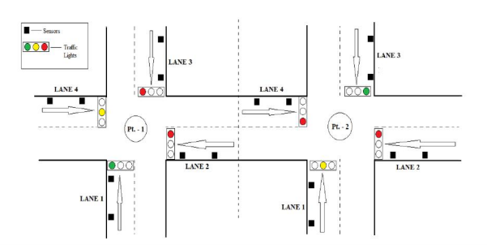In this proposed system, the traffic lights are LEDs and the car counting sensor is an ultrasonic sensor. Both blocks are connected to a Microcontroller using physical wires. The Microcontroller is the traffic light controller which receives the collected sensor data and manages the traffic lights by switching between green, yellow and red. The Microcontroller computes the number of cars in the street of the intersection it is monitoring based on the distances measured by the ultrasonic sensor and the timing between those measurements. The Microcontroller then sends the number of cars every minute to the local server. This communication is done using the Microcontroller serial port. The local server exchanges the data received with the cloud server in order to better predict the changes in timings of the traffic light. This communication is done using Wi-Fi. More specifically, the cloud server uses an equation that takes the data received (number of cars) as input then determines the time interval of LEDs needed for a smooth traffic flow. This calculated time is then compared to the current actual time of the LEDs (this data is saved in a database on the cloud server). The server then comes up with a decision. If the current actual green time is less than the calculated time, the decision is to increase the green time, else to decrease the green time.

Here are some key steps in the design thinking process for traffic management using IoT:

1. 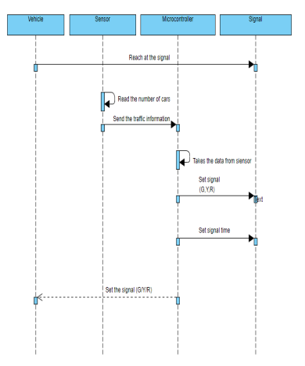**Empathize**: Understand the needs and pain points of various stakeholders involved in traffic management, such as commuters, traffic police, city planners, and emergency services. Conduct interviews, observations, and surveys to gather insights.
2. **Define**: Define the problem statement based on the insights gained during the empathize phase. For example, it could be improving traffic flow during peak hours or reducing response time during emergencies.
3. **Ideate**: Generate a wide range of ideas for addressing the defined problem. Encourage brainstorming sessions and collaboration among multidisciplinary teams. Consider IoT technologies such as sensors, cameras, data analytics, and cloud computing.
4. **Prototype**: Create low-fidelity prototypes or simulations of the proposed solutions. This could involve building physical models or using software tools for virtual simulations.
5. **Test**: Gather feedback on the prototypes from end-users and stakeholders. Iterate and refine the design based on the feedback received. Conduct pilot tests in real-world scenarios to evaluate the effectiveness of the proposed solutions.
6. **Implement**: Once the design has been validated through testing, proceed with implementing the traffic management system using IoT. This may involve deploying sensors, setting up communication networks, integrating data analytics platforms, and developing user interfaces.

By following this iterative design thinking process, you can create a traffic management system that leverages IoT technologies to improve road safety, optimize traffic flow, and enhance overall transportation efficiency.

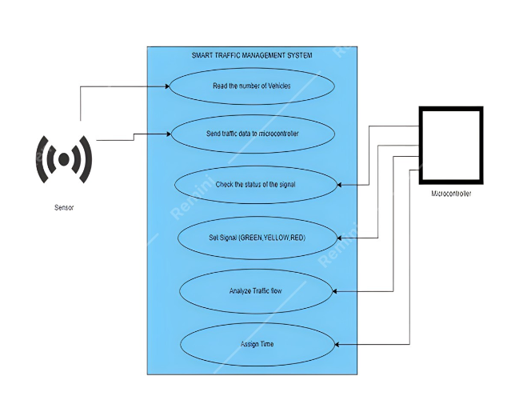

Flow Chart

